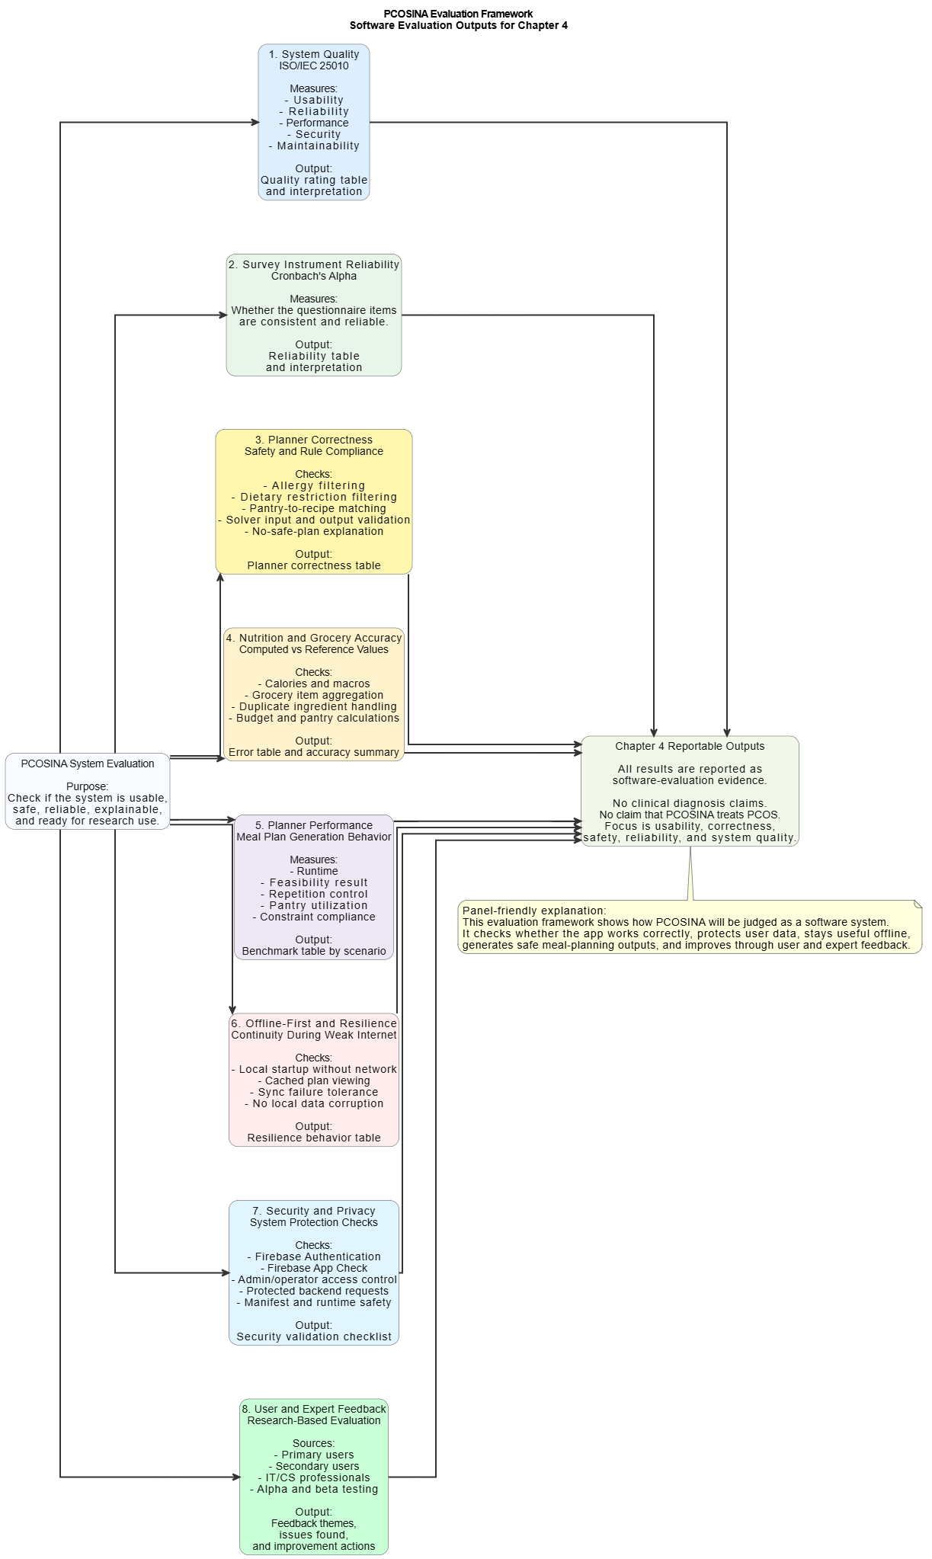
Figure 16. Effectiveness dimensions, metrics, and output artifacts

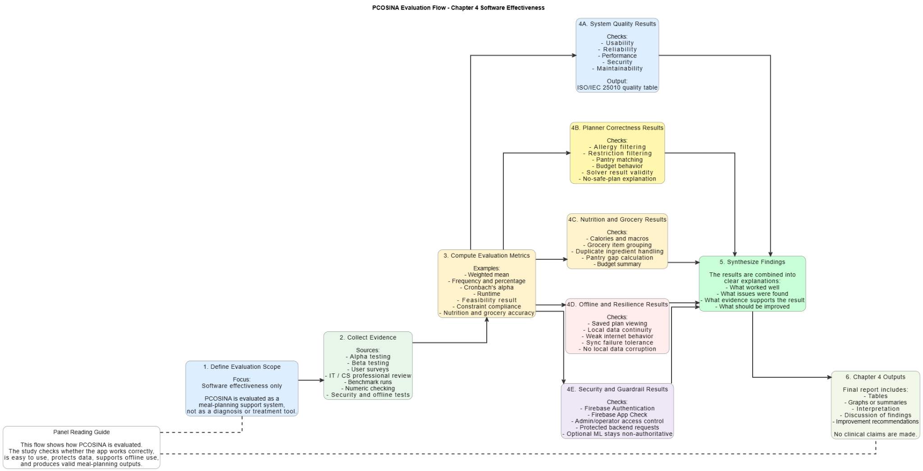
Figure 17. Effectiveness-evaluation flowchart

